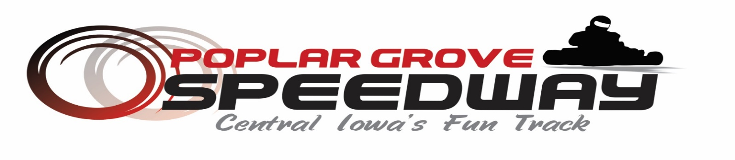
The following are the 2020 Sponsorship Opportunities that are available for 2 Cycle/4 Cycle Grand Nationals to be held at Poplar Grove Speedway, Kamrar, Iowa July 24th& 25th 2020

Class | Award Type | Cost per class | Sponsor Receives
Jr I Medium Clone-Duffy  Jr I Heavy Clone-Duffy  Jr II Medium Clone-Duffy | Duffy Class 1st | $500 | Free Premium Pit Spot, 2 Free Event Pit Passes, Media Coverage, Banner Display Area, Event Promotion
Jr II Heavy Clone-Duffy  Adult Medium Clone-Duffy | Trophy 2nd | $100 | Media Coverage, Sponsor List Area, Event Promotion
Adult Heavy Clone-Duffy  Briggs Animal Adult Super Heavy-Duffy | Trophy 3rd | $100 | Media Coverage, Sponsor List Area, Event Promotion
Sportsman Adult Clone-Duffy  Briggs Master LO206-Duffy | Trophy 4th | $100 | Media Coverage, Sponsor List Area, Event Promotion
2 Cycle Yamaha Heavy-Duffy  2 Cycle Jr I Heavy-Duffy | Trophy 5th | $100 | Media Coverage, Sponsor List Area, Event Promotion
2 Cycle Jr II Heavy-Duffy  2 Cycle Yamaha Spdy Midget w/L2 Pipe-Duffy | Entire Duffy Class | $800 | Free Premium Pit Spots, 4 Free Event Pit Passes, Media Coverage, Banner Display Area, Event Promotion
Restricted Box Wing
Stock Wing
Intermediate Wing
2 Cycle Unlimited
2 Cycle Super Stock Midget

Class | Award Type | Cost per Class | Sponsor Receives
Jr I Medium Clone-Money  Jr I Heavy Clone-Money | Money Class 1st | $500 | Free Premium Pit Spots, 2 Free Event Pit Passes, Media Coverage, Banner Display Area, Event Promotion
Jr II Medium Clone-Money  Jr II Heavy Clone-Money | Money Class 2nd | $400 | Free Premium Pit Spot, 1 Free Event Pit Passes, Media Coverage, Banner Display Area, Event Promotion
 | Money Class 3rd | $300 | Free Premium Pit Spot, 1 Free Event Pit Passes, Media Coverage, Banner Display Area, Event Promotion
 | Entire Money Class | $1100 | Two Free Premium Pit Spots, 6 Free Event Pit Passes, Media Coverage, Banner Display Area, Event Promotion

Class | Award Type | Cost per Class | Sponsor Receives
Adult Medium Clone-Money  Adult Heavy Clone-Money | Money Class 1st | $700 | Free Premium Pit Spot, 2 Free Event Pit Passes, Media Coverage, Banner Display Area, Event Promotion
2 Cycle Yamaha Heavy Pro | Money Class 2nd | $450 | Free Premium Pit Spot, 2 Free Event Pit Passes, Media Coverage, Banner Display Area, Event Promotion
 | Money Class 3rd | $325 | Free Premium Pit Spot, 1 Free Event Pit Passes, Media Coverage, Banner Display Area, Event Promotion
 | Entire Money Class | $1300 | Two Free Premium Pit Spots, 6 Free Event Pit Passes, Media Coverage, Banner Display Area, Event Promotion

Class | Award Type | Cost per Class | Sponsor Receives
Briggs Animal Heavy-Duffy and Money | Duffy/Money 1st | $1000 | Free Premium Pit Spot, 2 Free Event Pit Passes, Media Coverage, Banner Display Area, Event Promotion
 | Trophy/Money 2nd | $450 | Free Premium Pit Spot, 1 Free Event Pit Passes, Media Coverage, Banner Display Area, Event Promotion
 | Trophy/Money 3rd | $325 | Free Premium Pit Spot, 1 Free Event Pit Passes, Media Coverage, Banner Display Area, Event Promotion
 | Trophy/Money 4th | $100 | Media Coverage, Sponsor List Area, Event Promotion
 | Trophy/Money 5th | $100 | Media Coverage, Sponsor List Area, Event Promotion
 | Entire Money Class | $1800 | Two Free Premium Pit Spots, 6 Free Event Pit Passes, Media Coverage, Banner Display Area, Event Promotion

For questions or to help sponsor a class please contact:

Poplar Grove Speedway
%Holly Mortenson
2730 Poplar Grove Ave
Kamrar, Iowa 50595
Email: poplargrovespeedway@gmail.com
Holly’s Cell: 515-835-0475

